Design Pattern 3 – Adapter Pattern

This pattern consists of having an adapter that facilitates communication between two existing systems by providing a compatible interface.

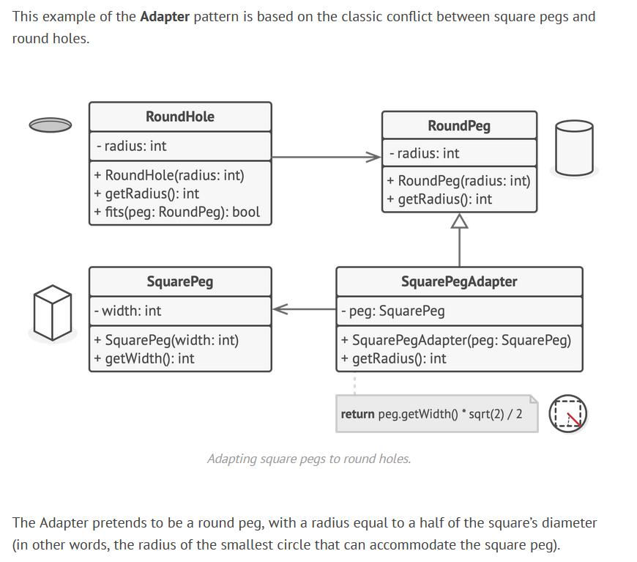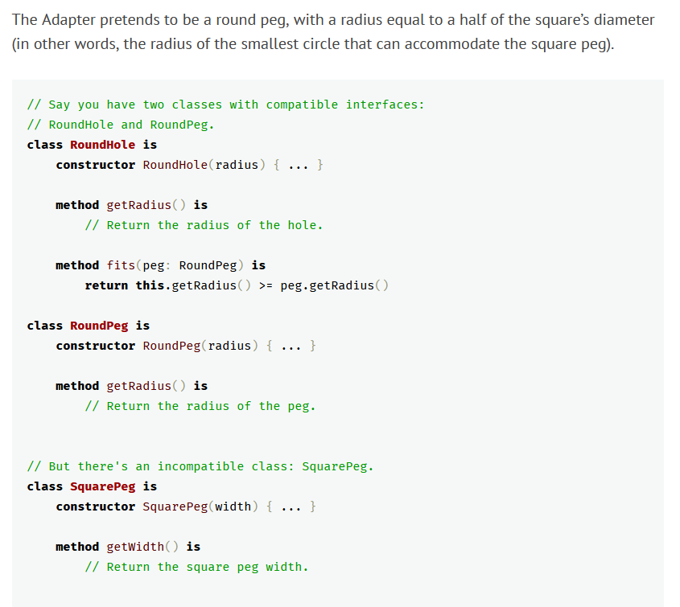**Code Snippet**

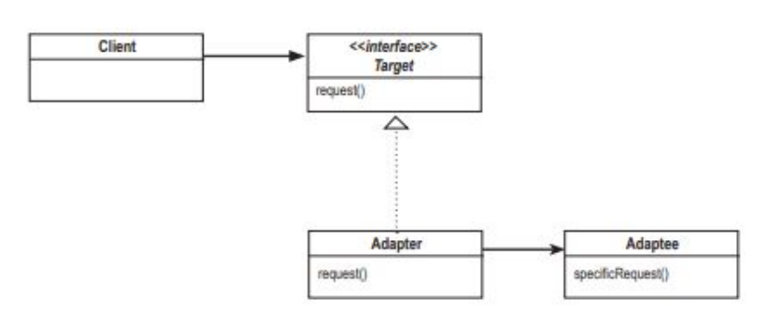**Structure**

**Code Location**

This adapter pattern is present in the project. The adapter class called LatexToUnicodeAdapter is in the following path:

*“src\main\java\org\jabref\model\strings\LatexToUnicodeAdapter.java”*

There are various classes that uses the adapter *LatexToUnicodeAdapter*, one example is the method *createAuthorList(String unparsedAuthors)* in the *BracketedPattern* class. The path of the *BracketedPattern* class is:

*“src/main/java/org/jabref/logic/citationkeypattern/BracketedPattern.java”*

**Justification**

As shown above, the adapter pattern is being used because the project has an adapter class called *LatexToUnicodeAdapter* that is used by various other classes, for example the *BracketedPattern* class. This adapter facilitates the use of a conversion from Latex to Unicode that other classes use to format the strings.